**Huddersfield Students’ Union website homepage: Proposal**

This year we have undertaken a digital rebrand and plans are in place to make changes to the student union website to reflect this and ultimately allow for our website to be instantly recognised as our brand. So far we have updated the font set across the website and updated to our new logo.

Although we are implementing these changes site wide. We are encountering some issues within our home page as changes we make are not pulling through. It is believed that this is because of our custom CSS file and the Union cloud CSS not being compatible together. Changes can be made at the ‘inspect element’ stage however the code cannot be found within the CSS coding.

Please find the current designs and how we are adapting this to reflect the new branding below.

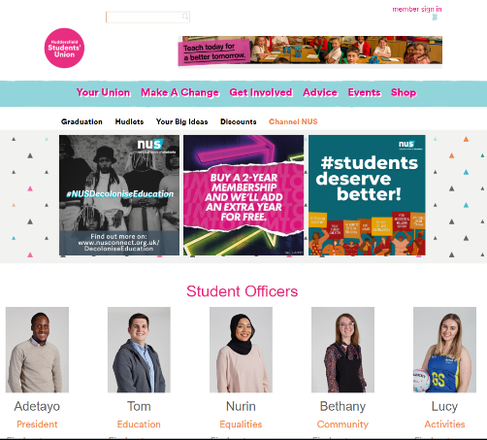

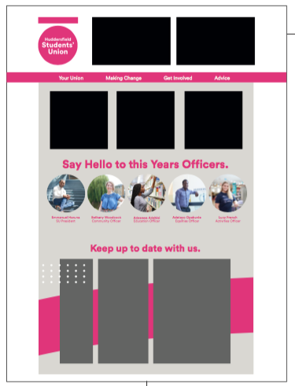

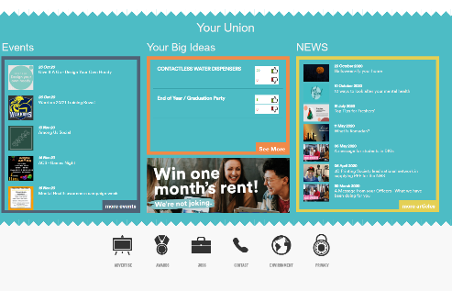

Current Home page. New Design.

*Please note that they long grey boxes on the new design are social media widgets.* The Middle black squares are the same web tiles we have on the home page and the top left black squares are the ad’s which will also stay the same.

As we have been working through how to make these changes on both our union cloud test website and the main SU website we have encountered the following problems.

1. Content such as pages or tabs won't appear on the homepage however the title of the content will. For example when trying to add the social media widgets the widget itself doesn’t appear on the homepage however it shows when in the back end preview.
2. Changes can be made at the inspect element stage however the code cannot be found within the CSS coding. Some of the CSS on the homepage is hard to locate, different files and some of them don't appear on the back end. Examples include Officer titles, the borders around news & updates sections and the navigation bar; see below for example.

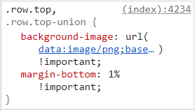

1. When adding the officer images to circles. A gap appears between the officer’s images on the home page and the text, we are struggling to remove. Please see the example bellow. This design feature will flow throughout the site so is important we get right.

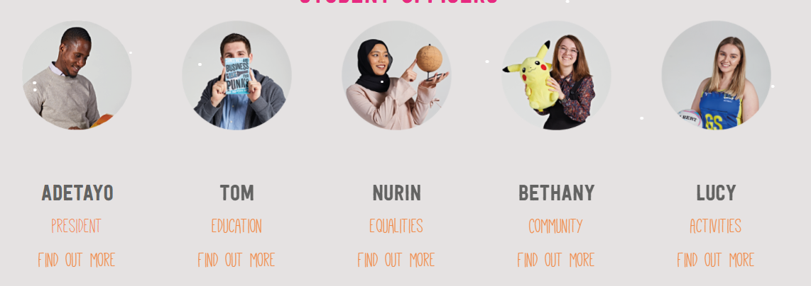

1. When adding hyperlinks for social media icons to the right of our homepage this interrupts the rest of the design for mobile. We have been able to complete this for desktop however this is not responsive.
2. Changing the colour of the man menu bar form blue to pink in our design can be done in inspect as the code is visible however the code is not visible in the back end. It is unclear which CSS file this sits in.

Not being able to move forward with these changes has meant that we are struggling to move forward with the rebrand.